SIMATS ENGINEERING (SAVEETHA SCHOOL OF ENGINEERING)
Department of Computer Science and Engineering
CO2 ASSESSMENT TOOL 2 – Architecture Design Assignment

Course Code: | CSA10 / CSA1063 | Course Title: | Software Engineering
CO Assessed: | CO2 | Assessment: | Assessment Tool 2 – Architecture Design Assignment
Weightage: | 20% | Total Marks: | 25
CO2 Statement: | Perform detailed requirements analysis, design scalable architectures, and prioritize features with a focus on cross-disciplinary skills
Student Name: | Jasim Asmaan A | Reg. No.: | 192421060
Date: | 03-08-2026 | Duration: | 60 minutes

Code of Conduct
I Jasim Asmaan A (Name / Reg No) certify that this submission is my original work and that I have adhered to the guidelines specified for this assessment. I understand that any violation of academic integrity rules will result in disciplinary action.
Signature of the Student: Jasim Asmaan A

Annexure A – Architecture Design Assignment

Question
Architecture Design Analysis for the Project:
AI-Based Smart Disaster Alert and Emergency Response Coordination System

1. Analyze System Requirements
- Study the given problem statement and identify the system objectives.
The main objective of the AI-Based Smart Disaster Alert and Emergency Response Coordination System is to provide early warnings for natural disasters and help people stay safe. The system uses AI and real-time data to predict disaster severity and send location-based alerts to affected users. It also helps government authorities and rescue teams coordinate emergency operations efficiently by providing accurate information and faster communication.
- Analyze the functional and non-functional requirements that influence the software architecture.
Functional Requirements
- User Registration and Login – The system should allow users to create an account and securely log in to access disaster-related services.
- Real-Time Disaster Monitoring – The system should continuously collect weather and sensor data to monitor disaster conditions.
- AI-Based Disaster Prediction – AI should analyze the collected data and predict the severity of disasters in different locations.
- Location-Based Alert Notification – Users should receive instant alerts based on their current location whenever a disaster is detected.
- Shelter and Emergency Service Finder – The system should display nearby shelters, hospitals, food centers, and first-aid facilities.
- Emergency Contact Information – Users should be able to access emergency helpline numbers and official government contact details.
- Admin Dashboard – Administrators should monitor disaster reports, manage alerts, and coordinate rescue operations from a centralized dashboard.
Non-Functional Requirements
- Security – The system should protect user information using secure login and data encryption.
- Performance – The application should process disaster data quickly and send alerts without delay.
- Reliability – The system should work continuously during emergencies and provide accurate information.
- Scalability – It should support a large number of users during disaster situations without affecting performance.
- Availability – The application should be available 24×7 so that users can access emergency services at any time.
- Maintainability – The system should be easy to update and maintain whenever new features or disaster types are added.
- User-Friendly Interface – The application should have a simple and easy-to-use interface so that people of all age groups can use it without difficulty.
- Government & Regulatory Authorities | Ensure compliance with financial regulations and audit requirements.

Stakeholder | Roles and Responsibilities
Citizens | Receive disaster alerts, follow safety instructions, and report emergency situations when required.
Disaster Management Authority | Monitor disaster conditions, coordinate rescue operations, and manage emergency resources effectively.
Rescue Teams | Respond to emergency alerts, rescue affected people, and provide immediate assistance.
Police & Fire Department | Maintain public safety, manage evacuations, and support rescue and relief operations.
Hospitals & Ambulance Services | Provide emergency medical treatment and transport injured people to nearby hospitals.
System Administrator | Maintain the application, database, security, and overall system performance to ensure continuous operation.

- Identify key quality attributes such as scalability, maintainability, reliability, availability, performance, and security.
Quality Attributes
- Maintainability
The software should be easy to update, fix, and improve whenever new disaster management features are required.
- Reliability
The system should provide accurate disaster predictions and send alerts without interruption during emergencies.
- Availability
The application should remain available 24×7 so that users can access emergency information whenever needed.
- Performance
The system should process real-time weather and location data quickly and deliver alerts without delay.
- Security
The system should protect user data through secure authentication, data encryption, and authorized access to prevent unauthorized usage.
- Scalability
The system should be able to support a large number of users during emergency situations without affecting its performance.

2. Select a Suitable Software Architecture
- Select an appropriate architectural style for the proposed system (e.g., Layered Architecture, Client-Server, MVC, Microservices, Event-Driven, Service-Oriented Architecture, Serverless, or Hybrid Architecture).
The proposed system uses Layered Architecture because it divides the application into different layers, where each layer performs a specific task. The main layers are the Presentation Layer, Business Logic Layer, AI Prediction Layer, Data Access Layer, and Database Layer. This structure makes the system well-organized, easier to develop, and simpler to maintain.
- Justify why the selected architecture is the most suitable for the given problem.
Architecture Layers:
- Business Logic Layer – Processes user requests and manages disaster-related operations.
- AI Prediction Layer – Analyzes weather, sensor, and location data to predict disaster severity.
- Data Access Layer – Retrieves and stores information from the database.
- Database Layer – Stores user details, disaster records, weather data, and emergency resources.
- Presentation Layer – Provides the user interface for citizens and administrators.

3. Draw the Software Architecture Diagram
- Design a clear architecture diagram illustrating the overall structure of the proposed system.
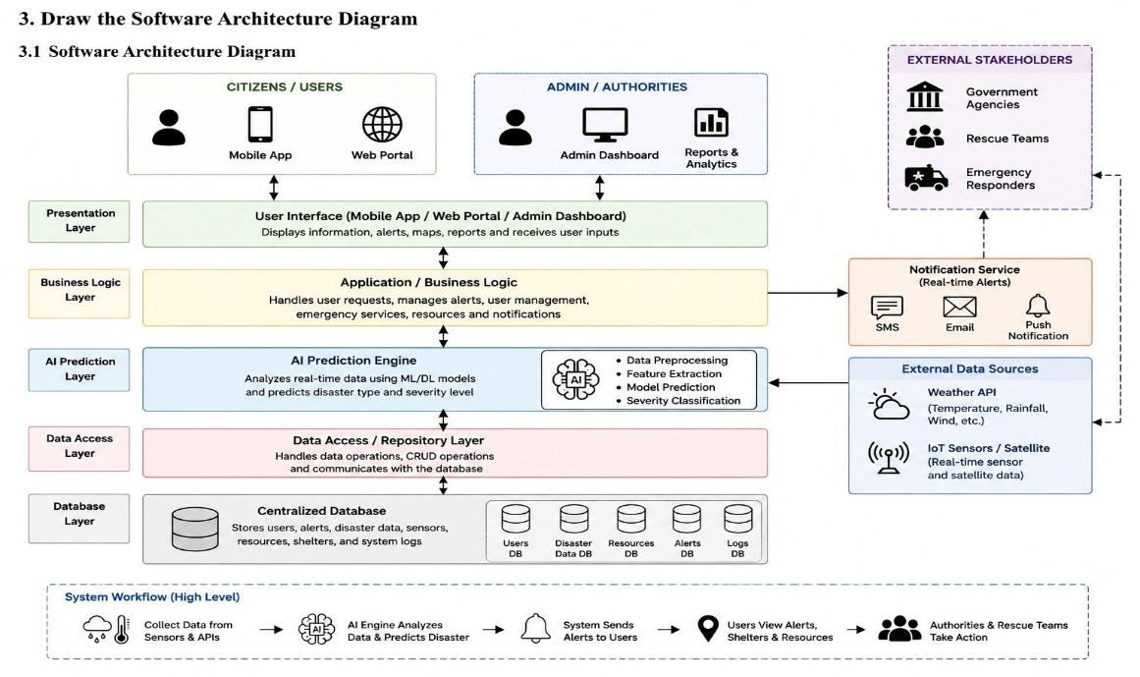

- Include all major layers/components, databases, external systems, APIs, and communication mechanisms.
The system consists of the Presentation Layer, Business Logic Layer, AI Prediction Layer, Data Access Layer, and Database Layer. It also includes Weather APIs, IoT Sensors, and a Notification Service. Each component performs a specific task to ensure accurate disaster prediction and quick emergency response
- Use appropriate software architecture notations and labels.
The system collects real-time data from Weather APIs and IoT sensors. The AI module analyzes the data and predicts disaster severity. The Business Logic Layer processes the results, stores them in the database, and sends alerts through the Notification Service to users and emergency authorities.

4. Explain Components and Their Interactions
- Describe the purpose and responsibilities of each architectural component.
The Presentation Layer allows users and administrators to access the system through a mobile app or web portal. The Business Logic Layer processes user requests and manages disaster-related operations. The AI Prediction Layer analyzes real-time data to predict disaster severity. The Data Access Layer handles communication with the database, while the Database Layer stores user details, disaster records, and emergency resources. The Notification Service sends alerts to users and emergency authorities.
- Explain how the components communicate and exchange data.
The components communicate through secure APIs and data exchange. The Presentation Layer sends user requests to the Business Logic Layer, which processes the information and interacts with the AI module and database. After processing, the Notification Service sends alerts to users and rescue teams.
- Illustrate the overall workflow of the system.
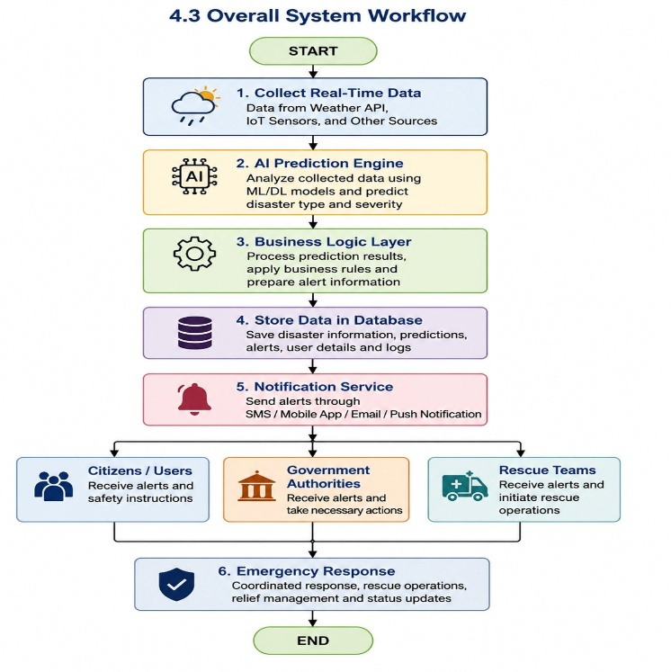

5. Discuss Quality Attributes
Evaluate how the proposed architecture addresses the following aspects:
Scalability
The system should be able to support a large number of users during disaster situations without affecting its performance. It should also be flexible enough to handle future features and increasing data.
Security
The system should protect user information through secure login, data encryption, and authorized access. This ensures that sensitive disaster information is accessed only by authorized users.
Performance
The application should process weather and sensor data quickly and send disaster alerts without delay. Fast performance helps users take immediate action during emergencies.
Reliability
The system should provide accurate disaster predictions and continue working smoothly even during critical situations. It should consistently deliver alerts without interruptions.
Maintainability
The software should be easy to update, test, and maintain whenever new features or disaster management requirements are introduced. This helps keep the system efficient over time.
Availability
The system should be available 24×7 so that users can access emergency information and receive alerts whenever a disaster occurs.

6. Justify Architectural Decisions
- Explain the rationale behind your architectural choices.
The proposed system uses Layered Architecture because it separates the application into different layers, such as the Presentation Layer, Business Logic Layer, AI Prediction Layer, Data Access Layer, and Database Layer. This makes the system easier to develop, understand, and maintain while ensuring that each layer performs a specific responsibility.
- Discuss the trade-offs considered while selecting the architecture.
The Layered Architecture provides several benefits, including better security, scalability, and maintainability. It also makes it easier to update individual modules without affecting the entire system. However, since data passes through multiple layers, it may introduce a slight processing delay. Even so, the advantages of improved organization and flexibility make it a suitable choice for this project.

- Explain how the chosen architecture supports future enhancements, system integration, and long-term maintainability.
The system can be improved by integrating advanced AI models for more accurate disaster prediction. Future versions may also include satellite and drone data, multilingual support, offline emergency alerts, and real-time resource tracking. These enhancements will improve the efficiency and reliability of disaster management.

